

Software Architectural & Design

**Version1.0**

**Quang Vuong**

**5/12/2019**

**VERSION HISTORY**

|  |  |  |  |  |  |
| --- | --- | --- | --- | --- | --- |
| **Version #** | **Implemented**  **By** | **Revision**  **Date** | **Approved**  **By** | **Approval**  **Date** | **Reason** |
| 1.0 | Quang Vuong | 5/12/2019 |  |  |  |
| 1.1 | Quang Vuong | 7/12/2019 | Team | 7/12/2019 | Team approve and update |
| 1.2 |  |  | Quoc Nhan | 5/1/2019 | Review document |
|  |  |  |  |  |  |

Content

1 Introduction 4

1.1 About this document 4

1.2 Definitions and Acronyms 4

2 Requirements Traceability Matrix 12

3 Architectural Documentation 4

3.1 Context Diagram 4

3.2 Portability 7

3.2.1 Portability (Physical) 11

3.2.1.1. Decomposition Rationale 11

3.2.1.2. Element Responsibilities Catalog 12

3.2.1.3. Relationship Responsibilities Catalog 13

3.2.2 Portability (Dynamic) 11

3.2.2.1. Decomposition Rationale 11

3.2.2.2. Element Responsibilities Catalog 12

3.2.2.3. Relationship Responsibilities Catalog 13

3.3 Usability 11

3.3.1 Decomposition Rationale 11

3.3.2 Element Responsibilities Catalog 11

3.3.3 Relationship Responsibilities Catalog 12

Table of Figures

1 Figure 1 Context Diagram 12

2 Figure 2 Performance 12

3 Figure 3.2.1 Portability (Physical) 12

4 Figure 3.2.2 Portability (Dynamic) 12

5 Figure 4 Usability 12

# Introduction

## About this document

This document contains the software architecture for the Architecture Studio project. It is advised that the reader familiarize themselves with the Architectural Drivers Specification document first before examining the architecture detailed in this document.

## Definitions and Acronyms

All terms and acronyms used in this document have been defined in the Sandcastle Glossary document. Please refer to that document for further information. If you didn’t get the glossary with this document, please contact a Sandcastle team member.

# Requirements Traceability Matrix



# Architectural Documentation

## Context Diagram

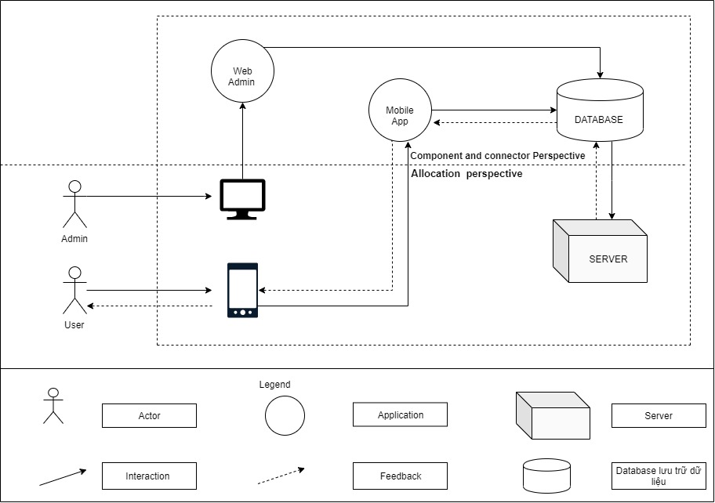 Figure 1 Context Diagram

## Portability

## 3.2.1 Portability (Physical)

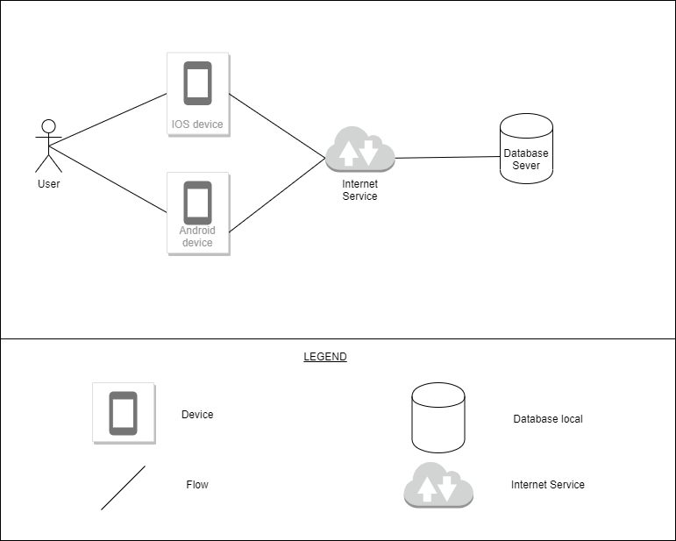

Figure 3.2.1 Portability

### 3.2.1.1 Decomposition Rationale

|  |  |
| --- | --- |
| **Associated Drawings:** Figure 3.2.1  **Associated Responsibilities:** Catalog 1, Catalog 2 | **Perspective:** Physical |
| This diagram shows one user can use on two foundation, 2 Foundation uses the same database | |

### 3.2.1.2 Element Responsibilities Catalog

**Catalog 1 Elements – Physical**

|  |  |
| --- | --- |
| **Associated Drawings:** Figure 3.2.1 | **Perspective:** Physical |
| **Element** | **Responsibilities** |
| Database Sever | Where data is stored |
| IOS device | It is device |
| Android device | It is device |

### 3.2.1.3 Relationship Responsibilities Catalog

**Catalog 2 Relationships**

|  |  |
| --- | --- |
| **Associated Drawings:** Figure 3.2.1 | **Perspective:** Dynamic |
| **Relationship** | **Responsibilities** |
| Data | This relationship will be used to connect the elements together. This symbol indicates an asset A will transfer the data to the B element. Element B will receive information data |
| Data flow | This relationship will be used to connect the elements together. This symbol indicates an asset A will transfer the data to the B element. Element B will receive information about the data and returns |

## 3.2.2 Portability (Dynamic)

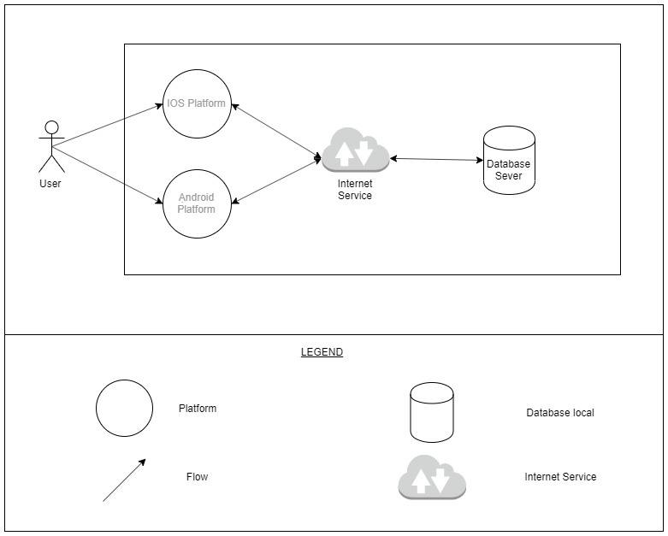

Figure 3.2.2 Portability

#### 3.2.2.1 Decomposition Rationale

|  |  |
| --- | --- |
| **Associated Drawings:** Figure 3.2.2  **Associated Responsibilities:** Catalog 1, Catalog 2 | **Perspective:** Dynamic |
| This diagram shows one user can use on two foundation, 2 Foundation uses the same database | |

### 3.2.1.2 Element Responsibilities Catalog

**Catalog 1 Elements – Physical**

|  |  |
| --- | --- |
| **Associated Drawings:** Figure 3.2.2 | **Perspective:** Dynamic |
| **Element** | **Responsibilities** |
| Database Sever | Where data is stored |
| IOS Platform | It is Platform |
| Android Platform | It is Platform |

### 3.2.1.3 Relationship Responsibilities Catalog

**Catalog 2 Relationships**

|  |  |
| --- | --- |
| **Associated Drawings:** Figure 3.2.2 | **Perspective:** Dynamic |
| **Relationship** | **Responsibilities** |
| Flow | This relationship will be used to connect the elements together. This symbol indicates an asset A will transfer the data to the B element. Element B will receive information data |
| Data flow | This relationship will be used to connect the elements together. This symbol indicates an asset A will transfer the data to the B element. Element B will receive information about the data and returns |
|  | Connection between two devices |

## Usability (static)

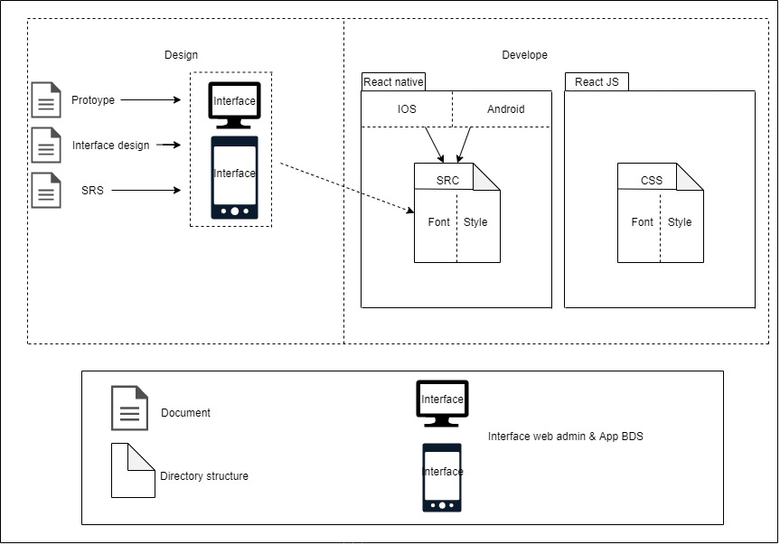

Figure 4: Usability

### Decomposition Rationale

|  |  |
| --- | --- |
| **Associated Drawings:** Figure 4  **Associated Responsibilities:** Catalog 1, Catalog 2 | **Perspective:** Static |
| This diagram shows how to design app interface for users to easily use | |

### Element Responsibilities Catalog

Catalog 1 Elements – Static

|  |  |
| --- | --- |
| **Associated Drawings:** Figure 4 | **Perspective:** Static |
| **Element** | **Responsibilities** |
| Document | contains the design |
| Directory structure | Directory structure of phase develope |
| Interface web admin & app BDS | Interface web & app in phase design |

### Relationship Responsibilities Catalog

**Catalog 2 Relationships**

|  |  |
| --- | --- |
| **Associated Drawings:** Figure 4 | **Perspective:** Static |
| **Relationship** | **Responsibilities** |
|  | B include A |